UMGC CHATBOT
VERSION 1
UNIVERSITY OF MARYLAND GLOBAL CAMPUS
CHATBOT SYSTEM


USER GUIDE
SWEN 670
Submitted By:
Helen Abraham
Evelyn Akinlosotu
Essaid Elboukhani
Romuald Priva Leuga Nousibouaba
Jon Masouh
Joe Ogunsanya
Vince Seen

april 26, 2020

This Page Intentionally Left Blank

Document History
Issue / Version Number | Change Description / Reason | Date
1 | Initial Release | April 26, 2020

Related Publications
Document Title | Document Number
UMGC ChatBot Project Plan | Not Applicable
UMGC ChatBot Software Requirements Specifications | Not Applicable
UMGC ChatBot Software Detailed Description | Not Applicable
UMGC ChatBot Test Plan | Not Applicable

List of Effective Pages
Section | Number of Pages | Change Number
UMGC ChatBot System, Issue 1, TOTAL NUMBER OF PAGES IN THIS USER GUIDE IS 29 CONSISTING OF:
Title (and blank page) | 2
Front Matter | 7
Chapter 1 | 2
Chapter 2 | 4
Chapter 3 | 2
Chapter 4 | 4
Chapter 5 | 2
Chapter 6 | 2
Chapter 7 | 2
Chapter 8 | 2

Table of Contents
Table of Contents ii
List of Figures iii
List of Tables iv
How To Use This User Guide v
Scope of This User Guide v
Purpose of This Manual v
Manual Organization v
Drawings and Diagrams v
SAMPLE Icons Used in the Manual v
Technical Support and Contact Information vi
1 General Information 3
1.1 Introduction 3
1.2 Overview 3
1.3 List of Abbreviations / Acronyms 3
2 Software Description and Data 5
2.1 Characteristics, Capabilities, and Features 5
2.1.1 Characteristics 5
2.1.2 Capabilities 5
2.1.3 Features 5
2.2 Descriptive Icons 5
2.3 Project Players 6
2.4 Support 6
2.5 Referenced Documentation 6
2.6 History of the Solution 7
2.7 Connections to the Application 7
2.7.1 Address 7
2.7.2 Authentication 7
2.7.3 Software Specifications 7
2.7.4 Hardware Specifications 7
3 Structuring of the Application 9
3.1 Layout 9
3.1.1 Process Interface – DialogFlow 9
3.1.2 Process Interface- IBM Watson 9
3.1.3 Screen Objects and Actions 10
4 Function Module Interface / Home Screen 11
4.1 Screenshot 11
4.2 Descriptions of Fields, Content 11
4.3 Description of Actions 11
4.4 Sequence of Screens 12
5 Troubleshooting 15
6 Maintenance 17
7 Glossary 19
8 Technical Support 21

List of Figures
Figure 1. UMGC Chat Icon 5
Figure 2. UMGC ChatBot – Chat In Process 6
Figure 3. DialogFlow Engine 9
Figure 4. IBM Watson Assistant 10
Figure 5. Home Screen Interface 11
Figure 6. Module Interface – City of Pasadena Home Page 12
Figure 7. UMCG Chatbot – Chat Activated 12
Figure 8. UMGC Chatbot – Chat Expended 13

List of Tables
Table 1. List of Icons Used in this Manual vi
Table 2. List of Abbreviations/Acronyms 3
Table 3. UMGC ChatBot System Developers 6
Table 4. ChatBot Software Specifications 7
Table 5. ChatBot Hardware Specifications 7
Table 6. Glossary 19

How To Use This User Guide

Scope of This User Guide
This user guide uses text formatting to highlight user-defined selections and commands. Format conventions used throughout this user guide are defined below.

Format | Purpose
Bold | Used to emphasize text the user must enter or select, including menu items, buttons, and commands
Italics | Used for emphasis or to identify screen names and text within ChatBot screens. The same text may be italicized if referring to a screen name or bolded if referring to a selection.

Purpose of This USER GUIDE
The purpose of this user guide is to describe the user steps for accessing and using the UMGC Chatbot system on the City of Pasedena website. The ChatBot system was designed to provide a more efficient and interactive dialog search system within the City of Pasedena, California website. Users will be able to find answers to pertinent questions by the general public.

User Guide Organization
The table below provides a summary for the content of each section within this user guide.
Chapter No. | Chapter Title | Summary
1 | General Information | Provides the general information and a list of acronyms.
2 | Software Description and Data | Provides software descriptions, characteristics, features, and information for the UMGC ChatBot system.
3 | Structuring of the Application | Provides the layout of the UMGC ChatBot, including icons, and functionalities.
4 | Function Module Interface / Home Screen | Provides operational procedures for Home Screen and ChatBot Function Module
5 | Troubleshooting | Provides maintenance procedures for the UMGC ChatBot system.
6 | Maintenance | Procedures illustrated to configure the UMGC ChatBot system.
7 | Glossary | Provides a list of technical terms used is this manual.
8 | Technical Support | Provides technical support contact information for the UMGC ChatBot.

Drawings and Diagrams
The drawings and diagrams in this manual are for informational purposes and generally accurate enough to give the user an idea of the look of the ChatBot user screens, icons, and selection menus.

Sample Icons Used in the Manual
This document may include instructions that may be important in the operation of the software. Some information may be added to give the user more insight into a particular function. In these cases, such icons are shown to attract the attention of the reader. Icons that may be included in this manual are listed in Table 1 below.

Table 1. List of Icons Used in this Manual
Icon | Function / Purpose
 | Chatbot Icon
 | To close the chat box
 | Maximized/Miniminzed

Technical Support and Contact Information
Should you need technical support for a product that is under warranty, extended warranty, or covered under a maintenance agreement, please contact UMGC Technical Support at umgc.edu/help or call 1-888-360-8682. Our Technical Services team will help you with diagnosing your product issues.

This Page Intentionally Left Blank

General Information

Introduction
This chapter provides an overview of the UMGC ChatBot System. A list of abbreviations in this document with their definitions is featured at the end of this chapter.

Overview
The UMGC ChatBot System was developed to enhance the search capabilities on the California State, City of Pasedena website. The ChatBot is a user-friendly, artificial intelligence (AI) software that can simulate a conversation (or a chat) with a user in natural language through websites. The ChatBot interfaces with the website and has knowledge of information on the website. It responds to user inputs on the host website and returns answers to the user’s questions.

List of Abbreviations / Acronyms
Table 2. List of Abbreviations/Acronyms
Abbreviation/Acronym | Definition
AI | Artificial Intelligence
IBM | International Business Machines. A multinational technology corporation.
NLP | Natural Language Processing
SDD | Software Design Document
SRS | Software Requirements Specifications
UMGC | University of Maryland Global Campus
User | Visitor or Customer on the City of Pasadena website.

This Page Intentionally Left Blank

Software Description and Data
The following sections describe the characteristics, capabilities, features, and specifications of the UMGC ChatBot software.

Characteristics, Capabilities, and Features
The following sections provide the specifications for the UMGC ChatBot software. Included are features, characteristics, and descriptions of major components.

Characteristics
The UMGC ChatBot system is designed with capabilities and features that enhance user seach on the host website. The system is programmed to utilize Natural Language Processing (NLP) to understand user questions and inputs. It translates user inputs into clear and relevant queries. It also validates user requests for unclear user inputs.

Capabilities
The UMGC ChatBot has the following capabilities:
- Natural Language Processing (NLP)
- Natural Language Understanding
- Contextual Awareness
- Anticipate Customer Needs

Features
- Integrates with the City of Pasadena website
- Integrates with website database
- Pre-trained
- Better answers

Descriptive Icons
The following figures describe the ChatBot icons involved in the chat process.

Figure 1. UMGC Chat Icon

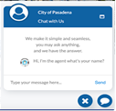
Figure 2. UMGC ChatBot – Chat In Process

Project Players

Table 3. UMGC ChatBot System Developers
Project Players | Roles
Helen Abraham | Tester
Evelyn Akinlosotu | Tester / Documentation
Essaid Elboukhani | Developer
Romuald Priva Leuga Nousibouaba | Developer / Tester
Jon Masouh | Developer / Tester
Joe Ogunsanya | Project Manager
Vince Seen | Developer / Tester

Support
The UMGC ChatBot project was developed with support by the University of Maryland Global Campus Software Engineering Department, Software Project (SWEN 670) Faculty and Staff.

Referenced Documentation
(1998, December 04). IEEE recommended practice for software design descriptions. IEEE Std 1016-1998. The Institute of Electrical and Electronics Engineers, Inc. Retrieved March 30, 2020 from https://www.cs.helsinki.fi/group/linja/resources/IEEE_Std_1016-1998.pdf
Ogunsanya, J., Abraham, H. Akinlosotu, E., Elboukhani, E.Masouh, J., Nousibouaba, R.P.L., and Seen, V. Software requirements specification (SRS) – chatbot system. Retrieved March 28, 2020 from https://drive.google.com/file/d/1XeBxxYVtJyiU2renaey9aExyVdIgp7yl/view?usp=sharing

History of the Solution
The UMGC City Chatbot system was developed to enhance the search capability of the website of the City of Pasedena, California. The Chatbot was to incorporate the city’s zonal address module on the current website into its chat dialog knowledgebase. This update provides a chat system that is capable of providing the user with the user’s address-specific information.

Connections to the Application
The user can access the ChatBot online by entering the City of Pasedena’s website address into a web browser. The website is accessible via any web browser, such as Internet Explorer 11, Google Chrome, Safari Firefox, etc.

Address
You must connect to the application using the following address: https://www.cityofpasedena.gov.

Authentication
Verify the correct City of Pasedena website by ensuring that the address provided in section 2.7.1 is entered in the web browser.

Software Specifications
Table 4 lists the software requirements and specifications necessary to successfully access and connect to the UMGC ChatBot application.

Table 4. ChatBot Software Specifications
Requirement | Specification
Operating System | Windows or MAC

Hardware Specifications
A computer is required for the accessing the UMGC ChatBot application. Appropriate computer hardware devices include the following:
- Personal Computer (PC)
- Laptop
- iPad
- Tablet
- Smartphone
The computer hardware must meet the following specifications listed in Table 5.

Table 5. ChatBot Hardware Specifications

Requirement | Specification
Internet Access | Broadband
RAM | 4GB (Minimum)
Processor | Dual Core, 4.0 GHz
Storage | 64GB (Minimum )
Screen Resolution | 1,024 by 768 (Minimum)

Function Module Interface / Home Screen
This section describes the different screens that define the modules interface of the Chatbot system. Figure 3 provides the Chatbot application user interface. Figure 3 shows the landing page or the starting screen of the City of Pasadena website. It contains the chat icon that the user can click on to get help. The icon exists on all the pages of the site.

Screenshot
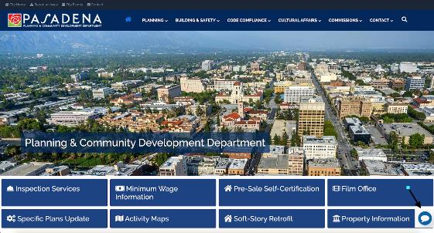
Figure 3. Home Screen Interface

Descriptions of Fields, Content
The user will utilize the Chatbot user interface when looking for help while navigating the City of Pasadena website. The system is able to provide the user with specific regulations, definitions, city’s standards and links to applications and permits. The services and possible queries are detailed in the SRS document for this UMGC ChatBot System.

Description of Actions
The chat feature is capable of answering the user questions either typed in or sent as voice messages. The system will be built to fetch data from common keywords configured with the chat engine systems. The responses will be both displayed as text or can be listened to.
Figure 4 shows the user’s click on the chat icon. In this screen, the chatbot system shall initiate the conversation and invite the user to ask for help. The user can expand the ChatBot or end the chat. The messages are either entered on the designated area to type a message or can be sent as audio messages.
Figure 5 shows the expanded chat box where the user can see all previous messages which can also be done using a scroll bar of the ChatBot.

Sequence of Screens

Home Screen
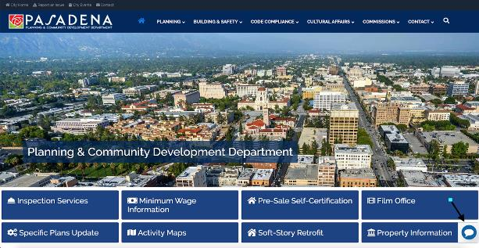
Figure 4. Module Interface – City of Pasadena Home Page

Screen with Chat Activated
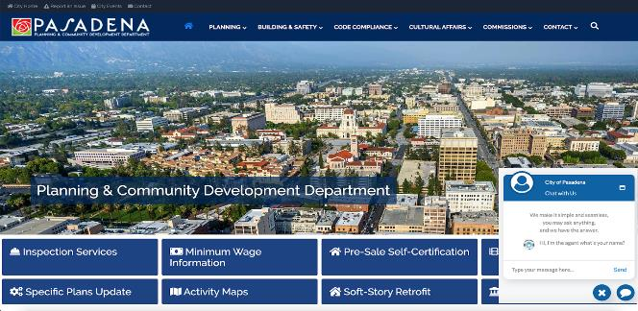
Figure 5. UMCG Chatbot – Chat Activated

Screen with Chat Expanded
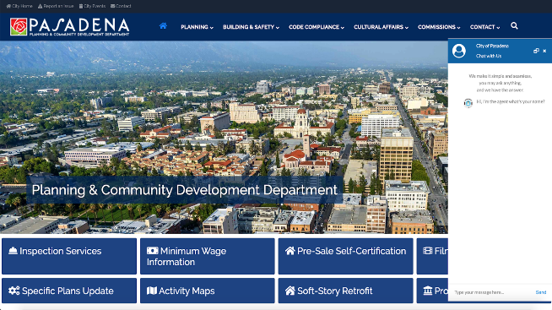
Figure 6. UMGC Chatbot – Chat Expended

This Page Intentionally Left Blank

Troubleshooting
This manual provides oftware driven procedures for troubleshooting of the UMGC ChatBot System. Before attempting to troubleshoot the UMGC Chatbot, refer to the contact information for UMGC technical support in the Technical Support section on page 21 of this user guide.

This Page Intentionally Left Blank

Maintenance
Refer to the Technical Support section on page 21 for contact information for UMGC technical support of maintenance issues.

This Page Intentionally Left Blank

Glossary
This is a glossary of acronyms and terms commonly used in this manual. Some acronyms are fully explained (including definitions). Others may only have the series of words that form the acronym.
Table 6. Glossary
Term | Definition
Application | A software program or group of programs designed for end users.
ChatBot | A computer program designed to simulate conversation with human users, especially over the Internet.
Dialog Flow | Anatural language processing (NLP) platform that can be used to build conversational applications and experiences for a company’s customers in various languages and on multiple platforms
IBM Watson | A cognitive computing platform originally developed by IBM to answer questions
Icon | A picture, image, or other representation.

This Page Intentionally Left Blank

Technical Support
If you should need technical support for a product that is under warranty, extended warranty or covered under a maintenance agreement, please contact UMGC Technical Support at umgc.edu/help or call 1-888-360-8682. Our Technical Services team will help you with diagnosing your product issues.

